Test Case: tc002_SPX_Dev5_Crear_Requisicion_Spot_Con_FAD_Tipo_Cobro_CC
Step 1 - Enter username and password and click to button Enter : Credentials Entered
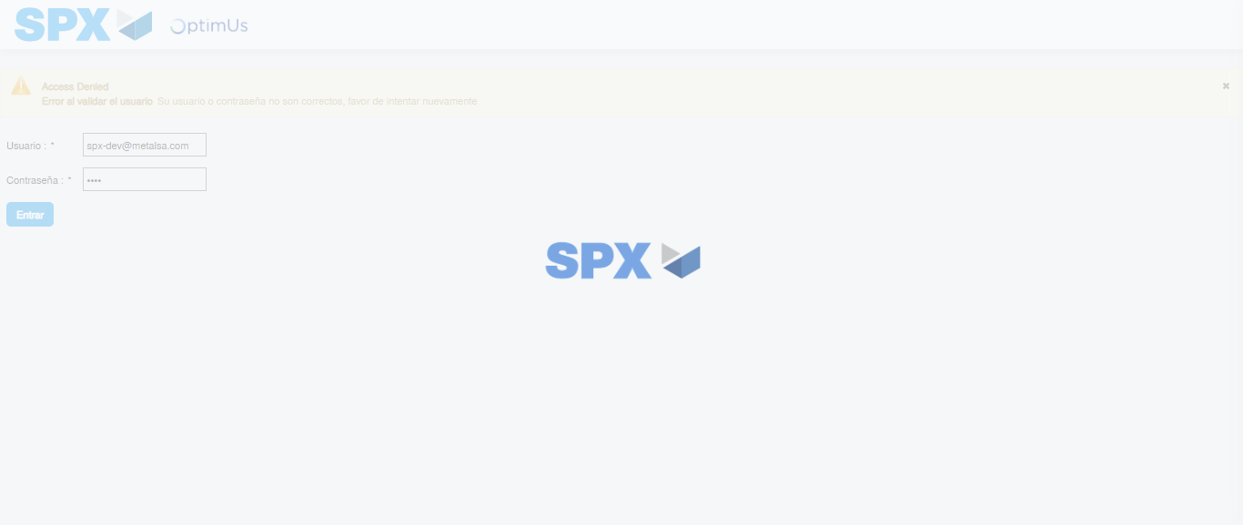Image file-name: QC_Testing-tc002_SPX_Dev5_Crear_Requisicion_Spot_Con_FAD_Tipo_Cobro_CC-1785960840381

Step 2 - Select to UEN and Access to Spot Buy Requisitions : UEN Correctly selected and Correct access
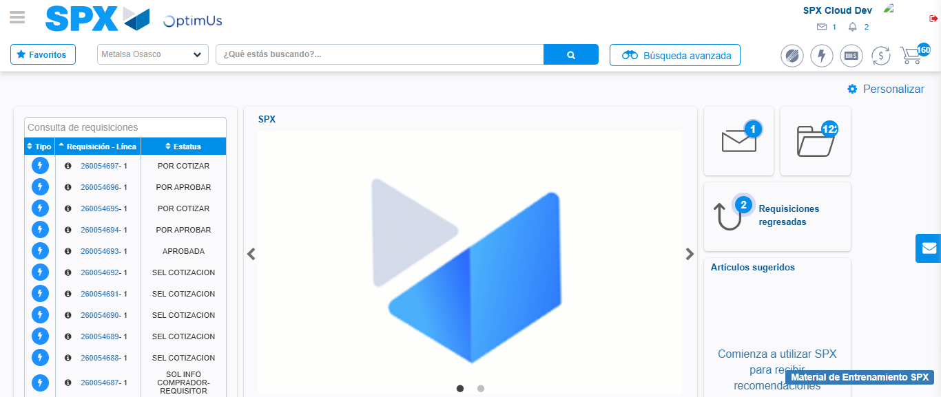Image file-name: QC_Testing-tc002_SPX_Dev5_Crear_Requisicion_Spot_Con_FAD_Tipo_Cobro_CC-1785960866553

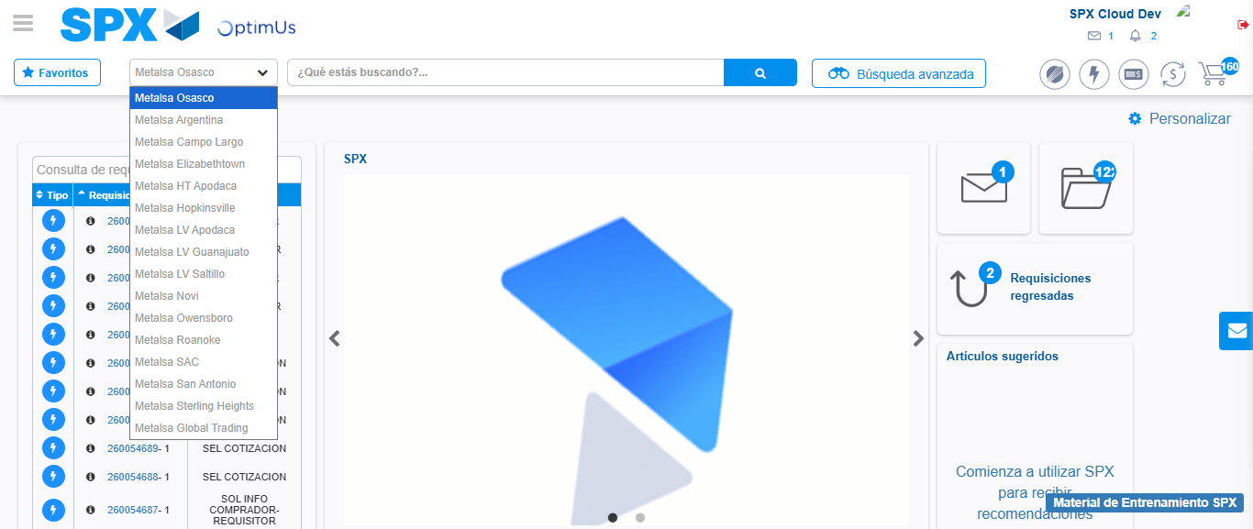Image file-name: QC_Testing-tc002_SPX_Dev5_Crear_Requisicion_Spot_Con_FAD_Tipo_Cobro_CC-1785960869183

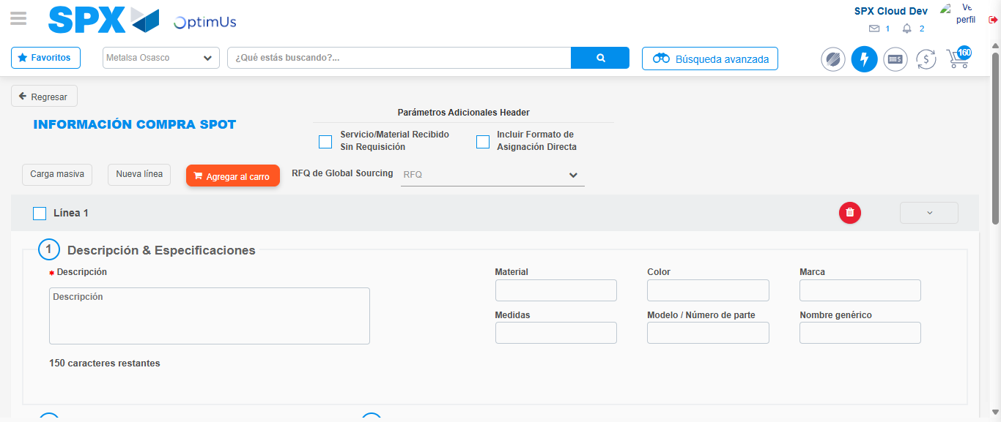Image file-name: QC_Testing-tc002_SPX_Dev5_Crear_Requisicion_Spot_Con_FAD_Tipo_Cobro_CC-1785960876273

Step 3 - Add FAD to Requisition: FAD Successfully Added
Image file-name: QC_Testing-tc002_SPX_Dev5_Crear_Requisicion_Spot_Con_FAD_Tipo_Cobro_CC-1785960876509

Image file-name: QC_Testing-tc002_SPX_Dev5_Crear_Requisicion_Spot_Con_FAD_Tipo_Cobro_CC-1785960876675

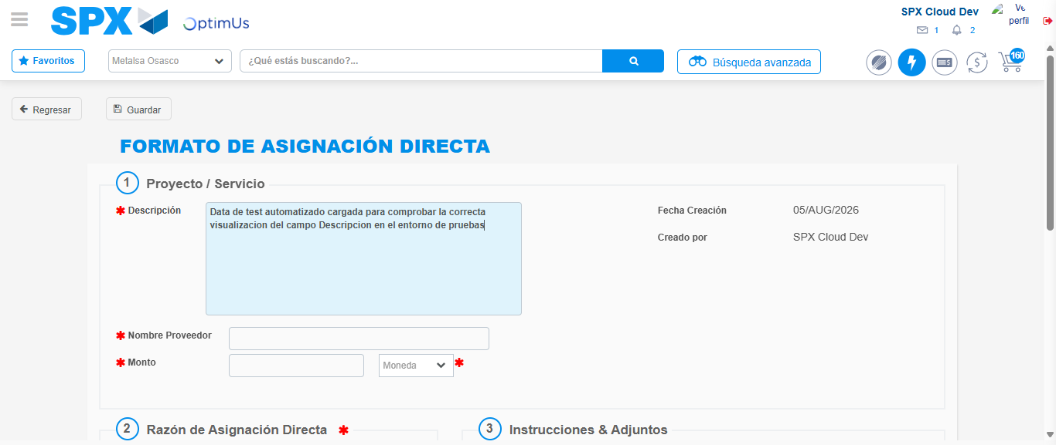Image file-name: QC_Testing-tc002_SPX_Dev5_Crear_Requisicion_Spot_Con_FAD_Tipo_Cobro_CC-1785960879369

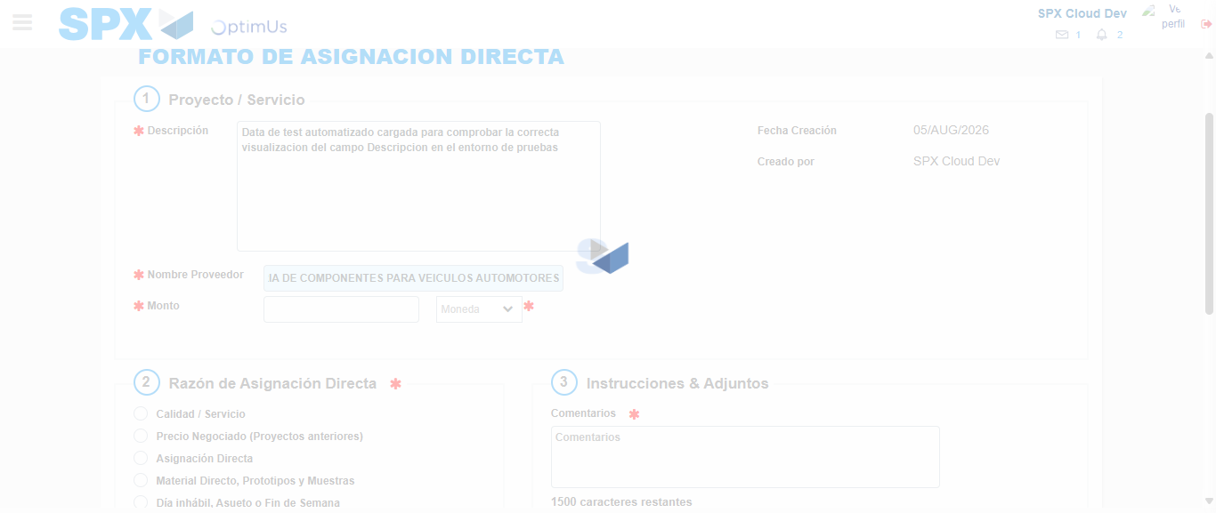Image file-name: QC_Testing-tc002_SPX_Dev5_Crear_Requisicion_Spot_Con_FAD_Tipo_Cobro_CC-1785960888463

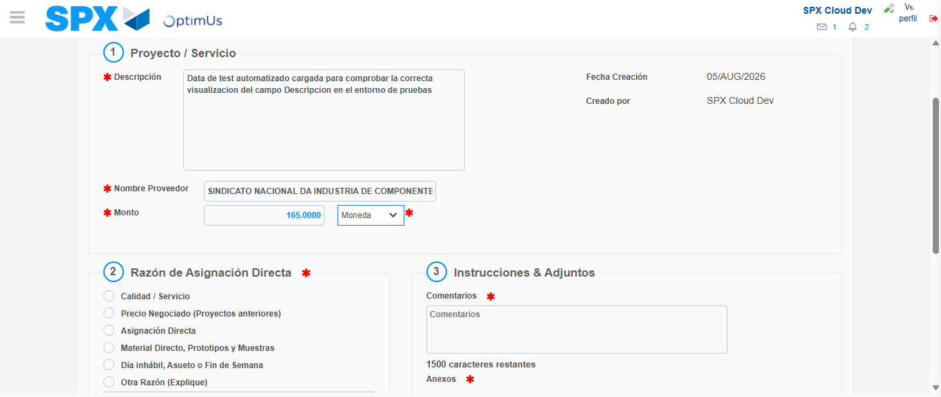Image file-name: QC_Testing-tc002_SPX_Dev5_Crear_Requisicion_Spot_Con_FAD_Tipo_Cobro_CC-1785960888855

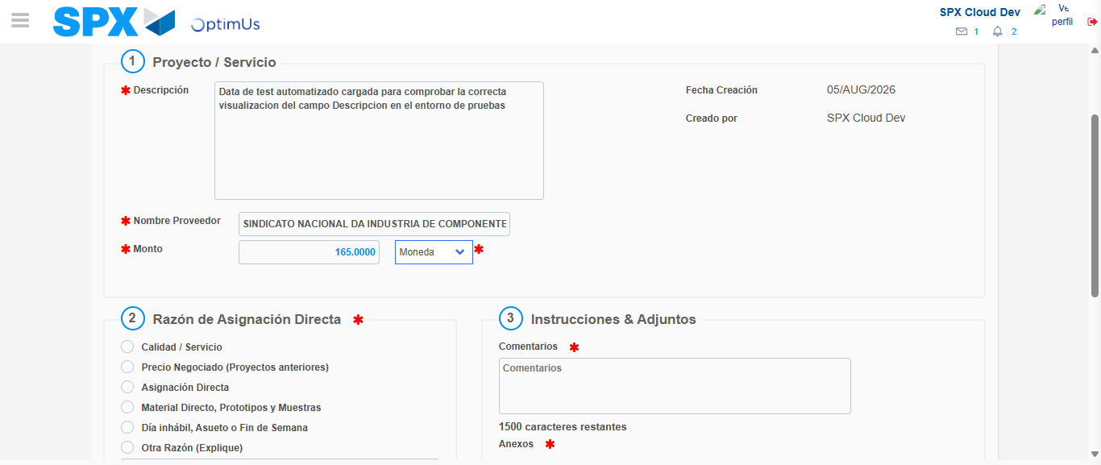Image file-name: QC_Testing-tc002_SPX_Dev5_Crear_Requisicion_Spot_Con_FAD_Tipo_Cobro_CC-1785960889088

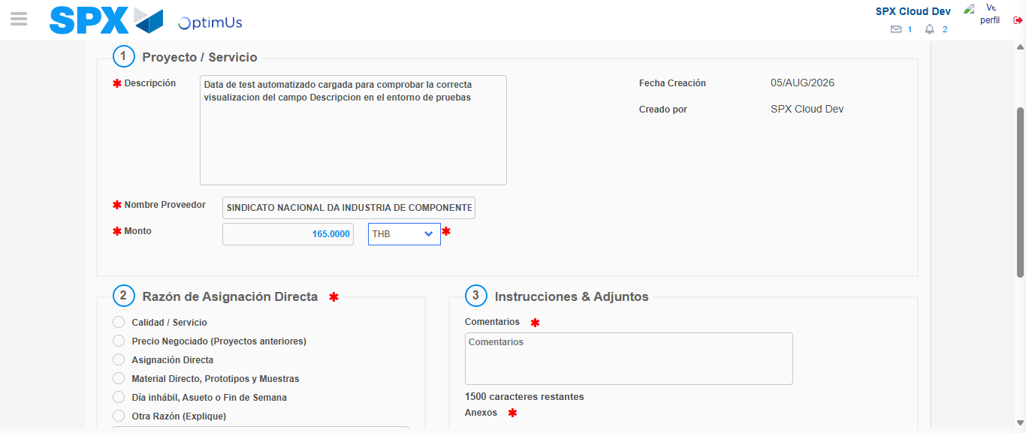Image file-name: QC_Testing-tc002_SPX_Dev5_Crear_Requisicion_Spot_Con_FAD_Tipo_Cobro_CC-1785960889410

Image file-name: QC_Testing-tc002_SPX_Dev5_Crear_Requisicion_Spot_Con_FAD_Tipo_Cobro_CC-1785960889640

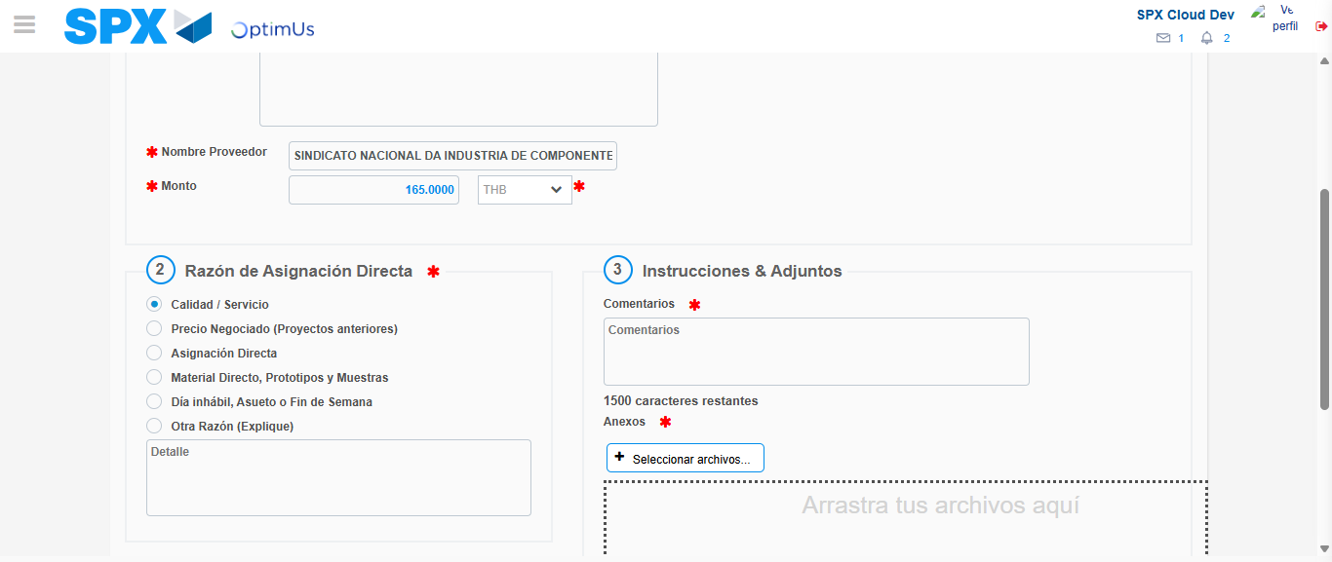Image file-name: QC_Testing-tc002_SPX_Dev5_Crear_Requisicion_Spot_Con_FAD_Tipo_Cobro_CC-1785960890466

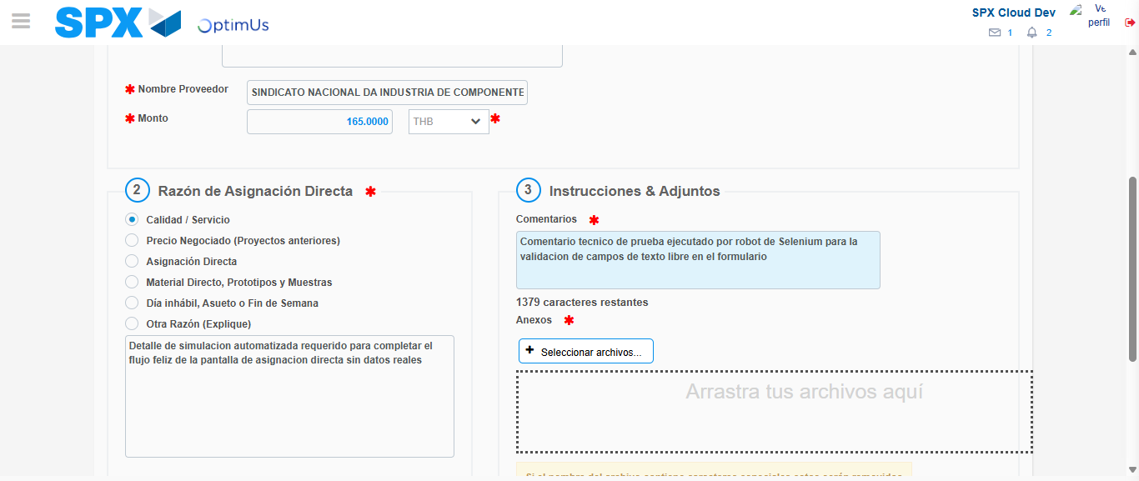Image file-name: QC_Testing-tc002_SPX_Dev5_Crear_Requisicion_Spot_Con_FAD_Tipo_Cobro_CC-1785960901437

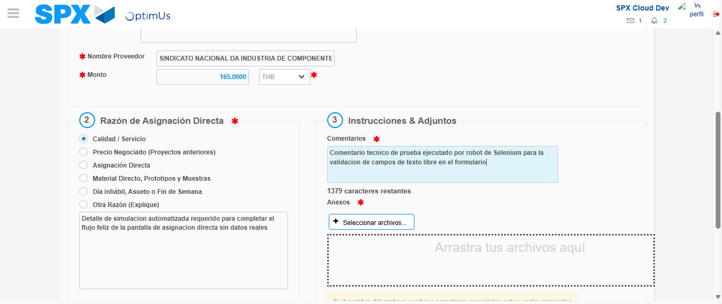Image file-name: QC_Testing-tc002_SPX_Dev5_Crear_Requisicion_Spot_Con_FAD_Tipo_Cobro_CC-1785960902045

Step 4 - Data Capture Spot Buy Requisition: Data captured correctly
Image file-name: QC_Testing-tc002_SPX_Dev5_Crear_Requisicion_Spot_Con_FAD_Tipo_Cobro_CC-1785960876509

Image file-name: QC_Testing-tc002_SPX_Dev5_Crear_Requisicion_Spot_Con_FAD_Tipo_Cobro_CC-1785960876675

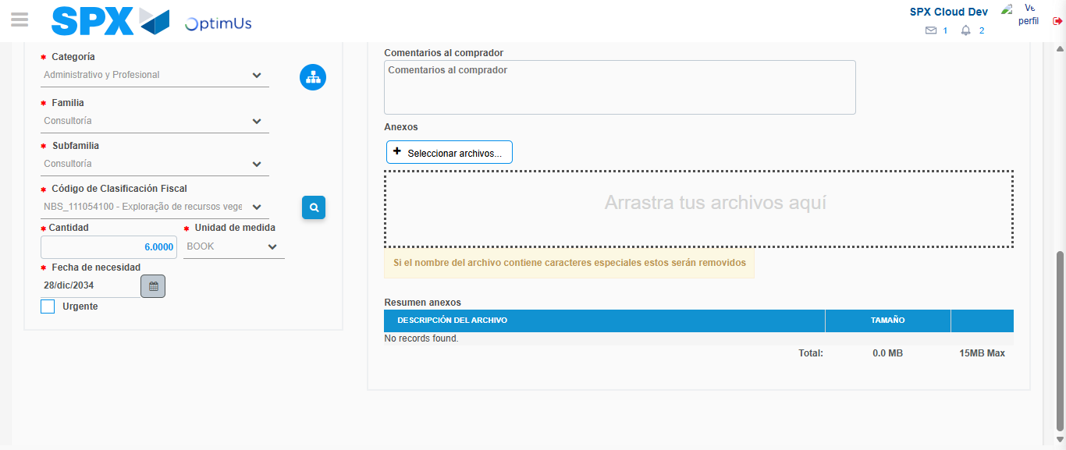Image file-name: QC_Testing-tc002_SPX_Dev5_Crear_Requisicion_Spot_Con_FAD_Tipo_Cobro_CC-1785960919490

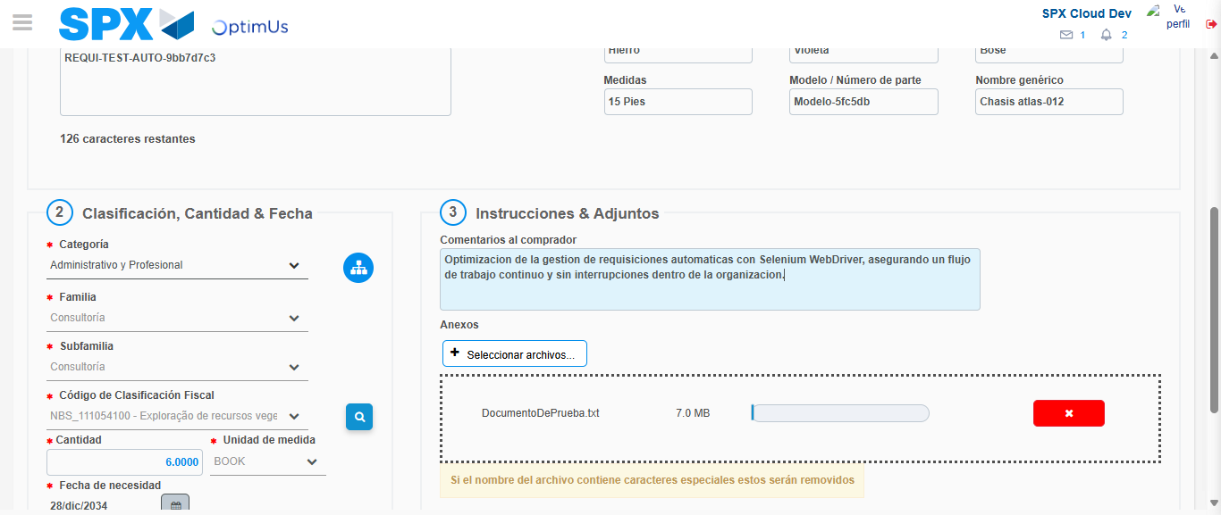Image file-name: QC_Testing-tc002_SPX_Dev5_Crear_Requisicion_Spot_Con_FAD_Tipo_Cobro_CC-1785960920238

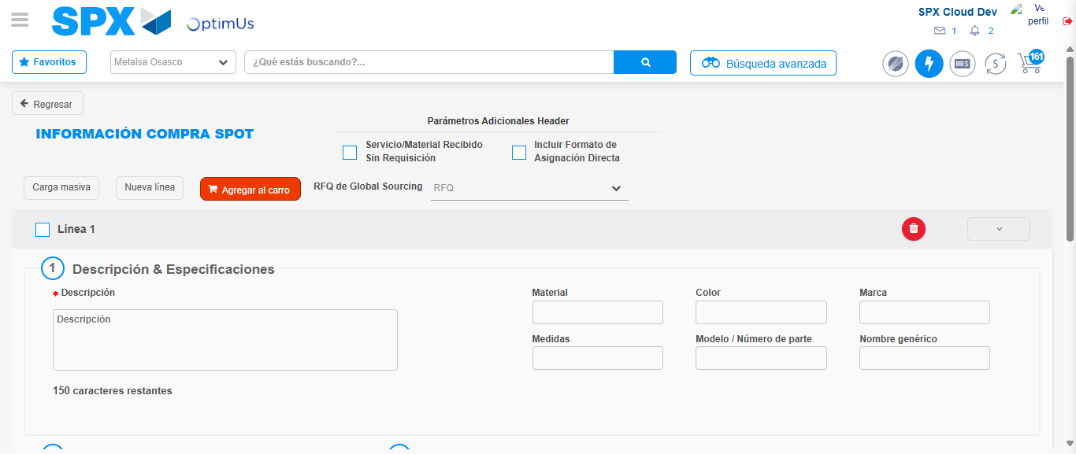Image file-name: QC_Testing-tc002_SPX_Dev5_Crear_Requisicion_Spot_Con_FAD_Tipo_Cobro_CC-1785960930160

Step 8 - Return to Main Page SPX : Return to Main Page SPX
Image file-name: QC_Testing-tc002_SPX_Dev5_Crear_Requisicion_Spot_Con_FAD_Tipo_Cobro_CC-1785960866553

Image file-name: QC_Testing-tc002_SPX_Dev5_Crear_Requisicion_Spot_Con_FAD_Tipo_Cobro_CC-1785960869183

Image file-name: QC_Testing-tc002_SPX_Dev5_Crear_Requisicion_Spot_Con_FAD_Tipo_Cobro_CC-1785960876273

Image file-name: QC_Testing-tc002_SPX_Dev5_Crear_Requisicion_Spot_Con_FAD_Tipo_Cobro_CC-1785960932365

Image file-name: QC_Testing-tc002_SPX_Dev5_Crear_Requisicion_Spot_Con_FAD_Tipo_Cobro_CC-1785960932522

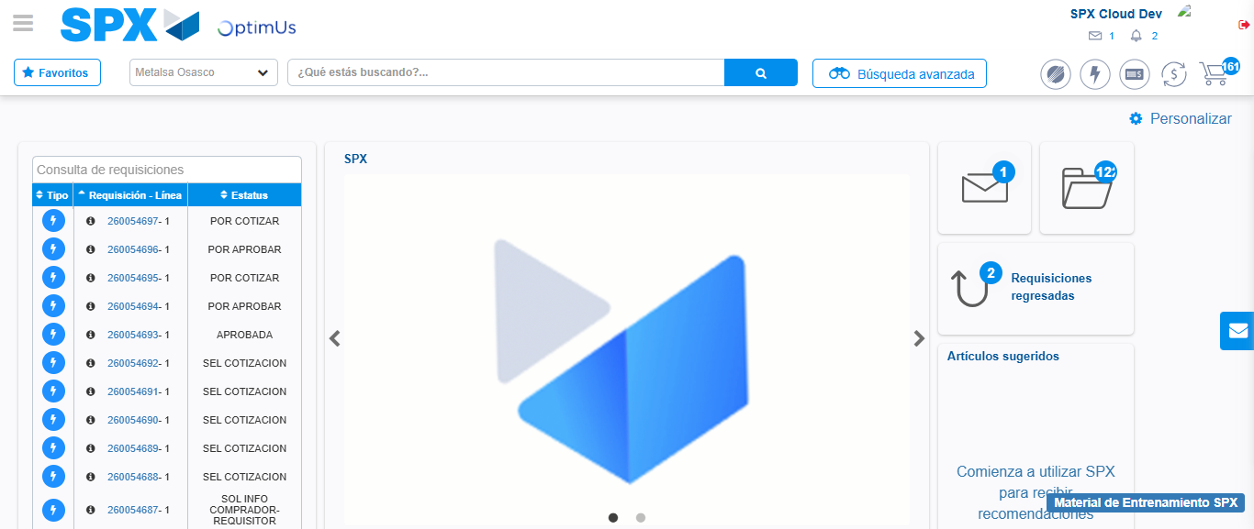Image file-name: QC_Testing-tc002_SPX_Dev5_Crear_Requisicion_Spot_Con_FAD_Tipo_Cobro_CC-1785960953533

Step 9 - Log Out : Log Out SPX
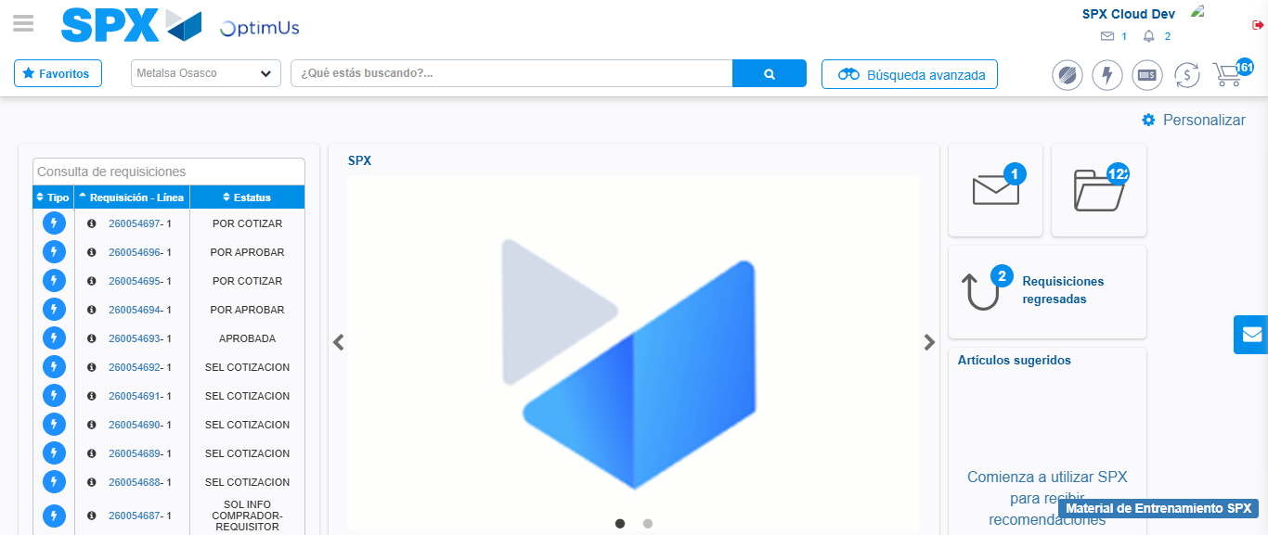Image file-name: QC_Testing-tc002_SPX_Dev5_Crear_Requisicion_Spot_Con_FAD_Tipo_Cobro_CC-1785960953830

